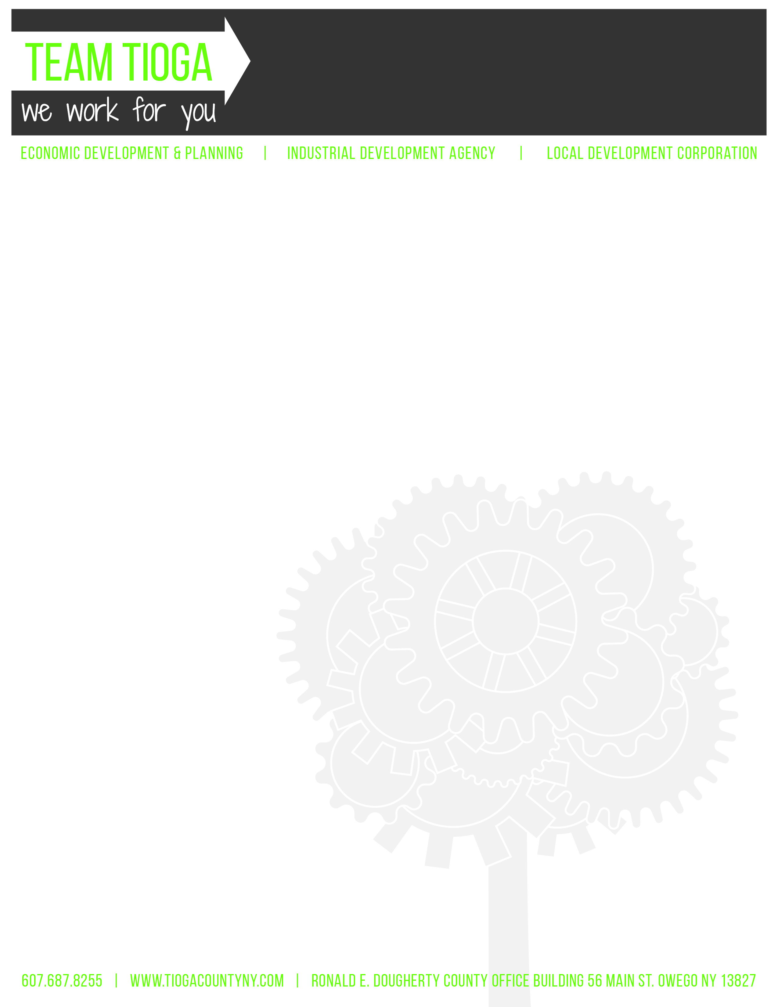

Tioga County Industrial Development Agency

January 6, 2021 – 4:30 pm

Ronald E Dougherty County Office Building

56 Main Street, Owego, NY 13827

ED&P Conference Room, 2nd Floor

Regular Meeting Minutes via Zoom

- Call to Order and Introductions-Chairwoman J. Ceccherelli called the meeting to order at 4:31 pm.

- Attendance
IDA Board Members
Roll Call: J. Ceccherelli, K. Gillette, A. Gowan, T. Monell, M. Sauerbrey, E. Knolles, J. Ward
Absent:
Excused:
Guests: C. Curtis, M. Griffiths, J. Meagher, L. Tinney. M. Freeze

- Privilege of the Floor: None

- Approval of Minutes
- December 2, 2020 Regular Meeting Minutes
Motion to approve December 2, 2020 Regular Board Meeting Minutes via Zoom, as written. (T. Monell, E. Knolles)
Aye-7 Abstain-0
No-0 Carried

- Financials
- Balance Sheet
- Profit & Loss
- Transaction Detail
Motion to acknowledge financials, as presented. (J. Ward, T. Monell)
Aye-7 Abstain-0
No-0 Carried

- ED&P Update: L. Tinney
  - Ms. Tinney reported that she attended the Southern Tier Network Board meeting that they had arranged with Spectrum representatives to talk about their plan for advancement. She also noted that the broadband study is complete, and she will share the executive summary with the board at the next meeting.
  - Ms. Tinney attended one municipal meeting at the Town of Nichols
  - ED&P has recently responded to one state lead
  - The ED&P Team is continuing to lead the Tioga County Economic Recovery Council in their efforts to implement the strategic plan.
  - There are currently 18 active DRI projects ongoing in the Village of Owego, six New York Main Street projects, with many of the projects in the environmental review application stage.
  - The Land Bank is actively working on a number of projects. Ms. Tinney will get a summary report from T. Saraceno to share with the board
  - Restore NY projects in Waverly and Owego-Waverly project is nearing completion, Owego project is not as far along, but is getting there
  - Ms. Tinney is in contact with INHS and SEPP for potential housing projects in the county
  - Workforce Development-B. Woodburn continues to work with the Broome Tioga Talent Taskforce and the Greater Binghamton Chamber of Commerce on workforce development plans
  - The Workforce Development Pipeline Study recently completed a roundtable with local leaders in education from all districts
  - B. Woodburn and B. Maffei are working on a grant application in order to create a centralized recruitment tool, and have received input from various local stakeholders including Stateline Auto, Crown Cork & Seal, Tioga Downs, Lockheed Martin, and Three Rivers Development. The Chamber and Tourism office will be able to use this tool as well once it is complete.
  - Agriculture-the annual Agricultural District Inclusions are underway. Ms. Tinney reported that M. Griffiths attended a meeting regarding a proposed Farmers Market Project and she will continue to work with the property owner to assist in advancing that project. The Ag Value Chain study is also progressing.
  - ED&P is working on 13 potential grants, 6 pending grants, 18 active grants, and has completed work on 2 grant projects: the Census Outreach grant and Village of Spencer Nichols Park Historic Register project, which A. Hendrickson extensively worked on
  - ED&P conducted a tax-exempt property analysis for the villages in the county that shows the number of properties that are tax-exempt as well assessed value, property acreage etc.
  - ED&P completed a solar map to demonstrate the impact of solar projects on agricultural land in the county

- Project Updates: L. Tinney
- Owego Gardens II
1. PILOT Closed
2. Agency fee & Land purchase balance due paid in full
- Ms. Curtis reported that the PILOT was closed in December, and the IDA did receive the agency fee and the land purchase balance
- Ms. Tinney reported that Department of Health (DOH) has not yet given their approval for the water system. Once DOH gives their approval, the project can go out to bid. The project also needs to the approval from Suez to move forward. It is anticipated that the work will begin next week. Suez will also require two developer agreements for new construction projects: one for the water main for the townhouses, and another for the overall tank project. J. Meagher has confirmed that the IDA is the appropriate signer for the agreements. Ms. Tinney also added that Home Leasing’s anticipated start date of December 21, 2020 has been pushed back due to weather.
Motion to authorize any officer to sign the Suez developer agreements for the Owego Gardens II project contingent upon J. Meagher’s review of final agreement. (J. Ward, T. Monell)
Aye-7 Abstain-0
No-0 Carried

B. CNYOG
1. Owego Apalachin CSD Letter of Support
2. Town of Owego Letter of Support
3. Tioga County Letter of Support
- Ms. Curtis noted that the IDA has received letters of support from Owego Apalachin CSD, Town of Owego and Tioga County to extend the CNYOG PILOT. Because it is affecting the tax cap limit for all of the municipalities negatively, Ms. Tinney sent a letter to Crestwood explaining the situation and asking them to sign the new PILOT agreement.
C. Solar Maps

D. Tax Exempt Properties Data-Ms. Curtis noted that the data in these maps is from villages in the county only.
1. Pie Chart Maps
2. Analysis

E. DRI – Update
1. DRI Proposal – INHS Project Description
2. TCIDA Letter to HTFC
- Ms. Curtis reminded the board of last meetings discussion regarding the updated DRI proposal for Ti-Ahwaga and INHS. This proposal will roll $290,000 in funding under the existing DRI multi-site project, have the IDA administer the new Ti-Ahwaga project, and have the board consider a proposal from INHS for the relinquished funds. Ms. Curtis referred to the attached letter to the Housing Trust Fund Corporation from the IDA, and explained that M. Sauerbrey would sign the letter on the IDA’s behalf. The letter explains the aforementioned updates to the DRI project and asks them to give permission to the updates.
- Committee Reports: C. Curtis
A. Public Authority Accountability Act (PAAA)
- Audit Committee Report: A. Gowan, E. Knolles, J. Ward
a. No report
- Governance Committee: J. Ceccherelli, A. Gowan, E. Knolles
a. No report
3. Finance Committee: J. Ceccherelli, A. Gowan, J. Ward
a. No report
4. Loan Committee: S. Thomas, A. Gowan, R. Kelsey, K. Dougherty, D. Barton,
J. Ward, E. Knolles
a. No report
5. Railroad Committee: M. Sauerbrey, K. Gillette, T. Monell
a. Leaning Pole
- Ms. Curtis reported that there is a pole leaning over the railroad tracks. She will be obtaining quotes for removal and replacement of the pole and share with the Railroad Committee. The Railroad advised that since they did not put the pole in and have never used it for their operations, it does not fall under their maintenance requirements. J. Meagher will review and confirm that it is the IDA’s obligation to take care of the issue.
1. Maps – NYSEG & Google
2. RJ Corman closing 12-5-2020
3. RJ Corman Request; Updated Consent & Estoppel
Original Consent & Estoppel-
- J. Meagher reviewed the updated Consent & Estoppel agreement and had one concern. Under the operating agreement, the operator, in this case RJ Corman, is required to seek agency approval to transfer the agreement. RJ Corman has received financing, and the bank is asking that in the event of a foreclosure, they be allowed to transfer the operating agreement to a new operator without getting consent from the IDA. J. Meagher suggested that this would not be in the best interest of the board, and the board concurred that they would not be agreeable to signing this type of agreement. J. Meagher will get back RJ Corman to discuss changing this stipulation. J. Meagher will report back to the board on the agreement.

- PILOT Updates: C. Curtis
- Sales Tax Exemptions Update: C. Curtis
- Best Buy – $647,637.44/ Authorized $1,028,429-Ms. Curtis reported that this is within the allowable limit. Ms. Curtis reported that Best Buy believes that they have completed their project. Their agreement expired at the end of the year, and they will complete one final review and will most likely not need an extension.
B. Fire Tax Bills Distributed to PILOT Companies and Railroad
X. Grant Updates: C. Curtis
A. Ag Value Chain
B. Broadband Study
C. Town of Richford FEMA Application – Submitted 12-2-2020-Ms. Curtis reported that FEMA came back and requested a benefit cost analysis that they initially said would not need to be completed until next year. Ms. Curtis will prepare this over the next year and submit in full at the end of next year. She noted that the raising of the railroad in Richford will be put on hold for another year without these grant funds.
D. Monkey Run FEMA Application – Pending-Ms. Curtis reached out for a status update, and will continue to check.
E. ESD – Owego Utilities Capital Project – V&S water/sewer extension
1. Reimbursement request submitted 11-4-2020; reimbursement forthcoming

Ms. Tinney requested to discuss Midwestern Pet Foods. Ms. Curtis reported that she has received a PILOT application from Midwestern Pet Foods. They have been working on purchasing a second building in Waverly to expand their operations. Ms. Curtis asked J. Meagher’s office to prepare an inducement resolution acknowledging the receipt of the PILOT application.
Motion to approve inducement resolution acknowledging the receipt of a PILOT application from Midwestern Pet Foods. (T. Monell, A. Gowan)
Aye-7 Abstain-0
No-0 Carried
Ms. Tinney asked the board to approve the holding of a public hearing for the PILOT application in order to have the board take a vote on the application at the February hearing. J. Meagher suggested authorizing the setting of a public hearing.
Motion to authorize the setting of the public hearing for the Midwestern Pet Foods PILOT application. (A. Gowan, J. Ward)
Aye-7 Abstain-0
No-0 Carried
A. Gowan asked Ms. Tinney if the yearly fee would be applied to this PILOT, to which Ms. Tinney responded yes. The public hearing meeting will be held by Zoom. Ms. Tinney will send out a meeting notice to the board.

XI. Motion to move into Executive Session pursuant to Public Officers Law Section 105 at 5:05 pm to discuss financial matters, property acquisition, and personal matters. (M. Sauerbrey, J. Ward)
Motion to adjourn Executive Session at 5:19 pm (A. Gowan, J. Ward)
Motion to approve half of Ms. Curtis' salary increase for 2021 in the amount of $1800 be paid by HSA contribution. (A. Gowan, T. Monell)
Aye-7 Abstain-0
No-0 Carried

XII. Next Meeting: Wednesday February 3, 2020
XIII. Adjournment-Mr. Gillette motioned to adjourn the meeting at 5:20 pm.

