Information Technology – Legislative Committee Meeting
11.3.2026
- APPROVAL OF MINUTES
  - 10.06.2026 IT Legislative Committee Meeting

- FINANCIAL
  - Review of Budget Status and Financial News

- OLD BUSINESS
  - Shared Services Master Service Agreements
  - Town of Spencer Migration Project
  - Probation Upgrade
  - CID Upgrade
  - Cyber Security Training

- NEW BUSINESS
  - Cyber Security Training
  - Village of Owego EMS
  - Truck Wash Cameras

- PERSONNEL

- RESOLUTIONS
  - K35 Tyler Technology Annual Munis Software Renewal
  - K36 -MICROSOFT ENTERPRISE ENROLLMENT AGREEMENT
  - K45 Owego EMS Technology Separation Shared Services Removal
  - K46 ARPA Funds for MFA Tokens

- PROCLAMATION

Information Technology – Legislative Committee Meeting
10.06.2026
Attendance Legislators: Andrew Aronstam, Jake Brown, Ray Bunce, Tracy Monell, William Standinger, and Jo Ellen Rose
Staff: Jackson Bailey (County Administrator), Peter DeWind Esq. (County Attorney) Brandon Clark (Chief Information Officer), Ryan Ceruti (Deputy Director), Cathy Haskell (Legislative Clerk) Heather Canfield (Office Specialist II)
- APPROVAL OF MINUTES
  - Approval of 09.08.2026 IT Legislative Committee Meeting Minutes:
Legislator Andrew Aronstam made the motion, seconded by Legislator William Standinger to approve 09.08.2026 Information Committee Minutes as written. Motion carried.
- FINANCIAL
  - Review of Budget Status and Financial News

- OLD BUSINESS
  - Shared Services Master Service Agreements
    - Village of Owego
      - CIO Clark Stated Share Services agreement on hold until November.
    - Soil and Water
      - CIO Clark Stated ITCS is still waiting for the signed agreement.
  - Town of Spencer Project
    - The ITCS department has initiated the data analysis phase and revised the project plan for the upcoming migration initiative. The updated project will be presented to the Town of Spencer in October to obtain approval to proceed with equipment procurement required for the migration.

- NEW BUSINESS
  - Verizon Landline
    - CIO Clark reported that Verizon has sent out notifications that the FCC has approved the dismantle of copper phone lines. This affects the jail, all fire panels, and any dialers we have for security. Clark added Verizon has not officially indicated a termination date this is just a notification.
  - Tyler Munis Review
    - A resolution is scheduled to be presented in November for the new Tyler contract, outlining the terms and updates required for continued service. In preparation, the County Administrator and the ITCS Department are conducting a thorough review of all available modules to ensure each one is necessary, cost-effective, and aligned with operational needs. This evaluation will help confirm that the contract accurately reflects the County’s requirements before it is advanced for approval.
  - Cyber Security Training
    - ITCS is preparing to launch this year’s cybersecurity training. It will be delivered through NEOGOV.
    - All users will be assigned 11 short training modules, each contributing to the required annual training while offering deeper insight into current cybersecurity threats.
    - We are asking all staff to approach this year’s training with increased alertness and a mindset focused on preventing avoidable incidents.
  - VOC Flex Agreement
    - ITCS Department will be working towards creating new flex agreements for post sites with requirements for equipment and security to connect.
  - Village of Owego EMS
    - Owego EMS has expressed interest in transitioning from the Village shared services environment to a dedicated technical service provider to better support their operational needs. In response, CIO Clark will prepare and present a proposed project outlining the migration approach and recommended next steps at the November committee meeting.

- Executive Session
  - Was held from 9:55 to 10:07 to discuss Cyber Security. Motion made by Ray Bunce and seconded by Andrew Aronstam.
- PERSONNEL
- RESOLUTIONS
- PROCLAMATION

H1680 2026 – Year-to-Date Capital Budget Report

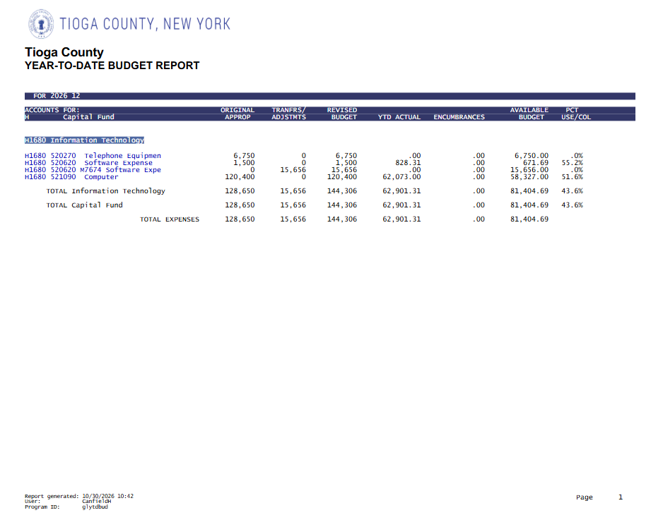

- A1680 2026 – Year-to-Date Budget Report

